Subject | Ағылшын тілі | Grade : 7
Teacher’s name: | Бейбитхан Ардак
Lesson № 7 | The 21 st of April
Theme of the lesson: | Natural remedies
Lesson objectives | Understand most specific information and detail while reading
Procedure | Resources | Accomplishment of tasks
Links to videos and online resources | https://youtu.be/OU1R_IXuUOY  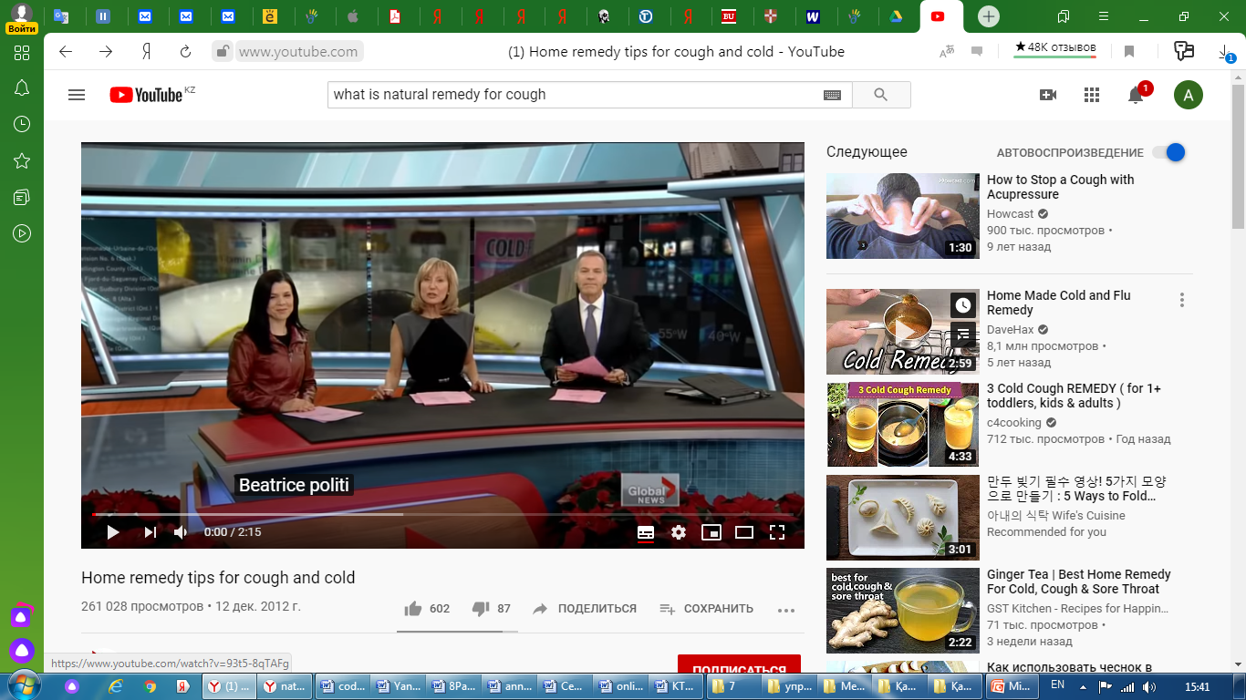
Answer | Answer the following questions (Төмендегі сұрақтарға жауап бер)  What is the video about ?  According to this video how can we get rid of a cough?
Study | Read the text about Nature’s helping hand on page 95. Open the presentation, learn new words and write them on your copybook.  Students Book: “Excel” Express Publishing 2017.  7 grade
Орында | Task 1  - Make 4 questions according to the video.  - Read the text and answer the following questions:  - Where is manuka honey produced?  - What are the health benefits of manuka honey?  - What is shubat and where can we buy it?  - What are the uses of shubat?  - Read the statements and decide which natural remedy they are about. Write M(manuka honey) or S(shubat)  This natural remedy …  - can help you relax at night. …  - can also be a delightful sweet. …  - might cost a lot of money. …  - can stop people getting a disease. …  Task 2.  Collect information about natural remedies in your country . What other natural remedies do you know? Write them on your copybook.
Рефлексия. | What did you learn from today’s lesson? (Бүгін не үйрендің?)  (1-2 сөйлеммен жазыңыз) | + немесе – белгілерін қой

